ACSL
American Computer Science League
2012 - 2013

Contest #3

Classroom Division

6. Graph Theory
Given the directed graph with vertices A, B, C, D, and E and
directed edges AB, AC, AD, BA, CD, EA, EC, CE, BD, and BE.
How many pairs of vertices have no directed edge?

7. Graph Theory
How many paths of length 3 exist in the following directed graph?
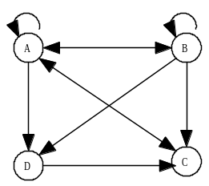

8. Boolean Algebra
Simplify the following Boolean expression:

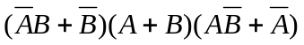

9. Boolean Algebra

How many ordered triples make this Boolean expression TRUE?

10. What Does This Program Do?
How many of the entries are not 0 after this program is run?
dim a(100)
for i = 2 to 25
a(i)=i
next i
for k = 2 to 25
if a(k) < >0 then
for j = 2*k to 25 step k
a(j)=0
next j
end if
next k

